Baby bottle heat transfer printing

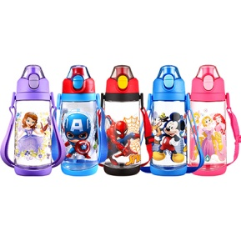

It has the following characteristics:

1) can be printing on the round and conical babay bottle.

2) one time printing with many color.

3) Vivid and bright color

4) simple process and match environmental protection.

Operate videos links: <https://youtu.be/i4JM33VhlxE>